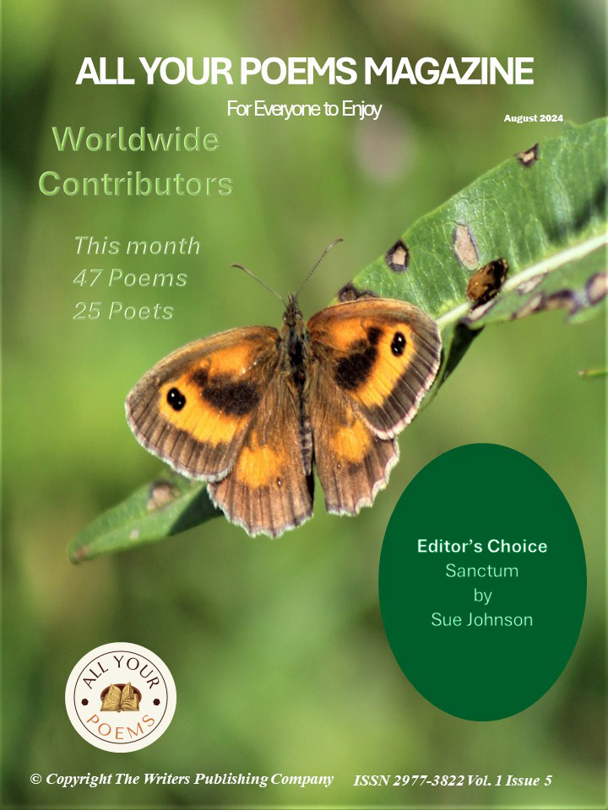


Welcome to the August issue of our magazine.
Thank you to all our contributors and readers. We are thankful for your support.
Please enjoy this issue by sharing and purchasing a copy from Amazon in print or for Kindle.
Deadline for the October issue is 18th September.
www.allyourpoems.com

© The Writers Publishing Company

Cover art by SGP

Contents
Editor’s Choice: Sanctum by Sue Johnson
Stopping by Corn Field on a Sunny Day by Deborah Guenther Beachboard
Toward the Sun by Deborah Guenther Beachboard
Seasons by Deborah Guenther Beachboard
Tranquil Aftermath by Terrance Anderson
Dartmoor by Terrance Anderson
How Black the Sea by Terrance Anderson
At the Border by Ron Shapiro
Here comes the rain by Ron Shapiro
Winter Days Sue Hassett
Reflections on time by Sue Hassett
Saturday lunchtime remembered by Andrew Senior
The Bells of St Peter’s by Jo Riglar
The broken branch by Duane Anderson
Different Life Styles by Duane Anderson
Tis the Season by Duane Anderson
Times passed by Lynn White

Meditation on Autumn by Lynn White
Oh dear, oh my, little Magpie by Sarah Cope
Hop on-board over thinkers by Sarah Cope
My Inner Child by Sarah Cope
Telling the Bees by Catrin Mari
29 Bloodlines by Catrin Mari
To Paint the Sun by Bobbi Sinha-Morey
White Lilac by Bobbi Sinha-Morey
The Soft air of daylight by Bobbi Sinha-Morey
Museum-Mazes by Emily Bilman
Water lilies by Emily Bilman
The Osprey by Emily Bilman
Is age number or excuse? by Pema Tshering
Noon Day Demon by Joan McNerney
Crazy Hot by Joan McNerney
Reservoir by Joan McNerney

The Canadian Indian by Joseph C. Ogbonna
The Canadian Inuit by Joseph C. Ogbonna
The Canadian Metis by Joseph C Ogbonna
No Fairytale Ending by Ann Garrett
Unfulfilled by Ann Garrett
Fatal Traction by John RC Potter
All things are one by Janet Guastavino
A Field of War By LaVern Spencer McCarthy
Braids by John Grey
The Soup and the Pita by Bon Roslan
Somewhere by Sarah Das Gupta
Bomb Song by Patricia Walsh
Time Waits for Nobody by Bohumila Ottova
Kings and Queens by Bohumila Ottova



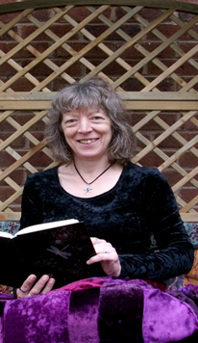

Sue Johnson is a poet, novelist and playwright. Her work is inspired by country walks, fairy-tales and visiting cafes and art galleries. Sue’s other interests include yoga, reading, studying Italian and cooking. Further information about her work can be found at www.writers-toolkit.co.uk

Sanctum

Walk the skylark path
parallel to the Avon
where the railway track once ran

hear ancient voices on the breeze
notice willowherb, meadowsweet
and angel trumpets

a tortoiseshell lands
at the edge of an inland sea
of dried grass

we reach the Sanctum
decorated with fragments of mosaic
mirror glass, shells, pieces of china

that carry me back in time
to Sunday afternoon tea
with flower-patterned bone china

I look towards Bredon
notice how the year is turning
and autumn will soon be here

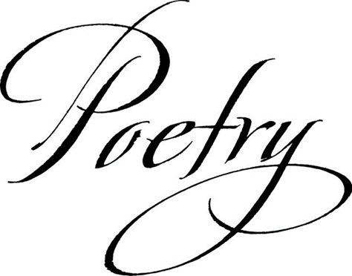

Deborah Guenther Beachboard
Deborah Guenther Beachboard began writing in 1993 and had poetry published in Modern Haiku, Sijo West, Amaze: The Cinquain Journal, Short Stuff, Twilight Ending and other online and in-print journals.After a ten-year hiatus (2006-2016 a long boring story), Deborah returned to writing and currently posts her poems to the uncurated online forum Poetry Soup under the pen name Chetta Achara.
https://www.poetrysoup.com/me/ChettaAchara
She makes her home in the Adna Valley in southwest Washington state.

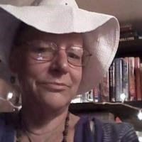

Stopping By Corn Field On A Sunny Day
with apologies to Robert Frost

Whose field is this I'm sure I know.
he's busy in the barn now though
and will not see me stopping here
to find his corn in rows and rows.

The stalks of corn are full of cheer
and cobs are tasty chased with beer;
and golden corn is calling me
to pluck and run, I have no fear.

It's late of day, no one will see
except the sun and she agrees
one or two will not be missed,
it's just a question of degree.

Heaven knows that I will weep
if I drive away with empty Jeep!
So now I have sweet corn to eat ~
sweet corn to eat before I sleep.

Toward the Sun
by Deborah Guenther Beachboard

Turn your face full toward the sun
where absence of shadow is found,
cold is dispelled and warmth abounds.
The game of life cannot be won
within shadows; come out, be done.

Seasons
by Deborah Guenther Beachboard

The seasons pay no mind to war
As summer sun fades into fall,
And winter wind raps on the door.

Falling leaves create a caul
For sleeping seed beneath the floor,
Where fears of men seem very small.

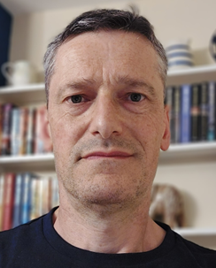

Terrance Anderson is 60 years old. Happily married, and father to 2 young adults, he discovered poetry at the ripe old age of 58. Having worked in many jobs over the years, he is now a cabinet maker by trade, living and working in Somerset. His first collection of poems, Unstructured, was published earlier this year

TRANQUIL AFTERMATH

It’s peaceful now

Peaceful and silent

The wind has stopped

The leaves settled

The rain all but petered out

The calm after the storm

Silent

Peaceful

Messy

And very, very wet

No more lightning lightening the sky

The thunder’s boomed it’s last

And it’s so quiet

Save for the drip, drip, drip

Dartmoor by Terrance Anderson

Exhilarating wind fills my lungs,

Blasting life back into my bones as I trudge your paths.

This is a pleasure that never wanes.

Your vast expanses.

Your little nooks.

Sheep keep a wary eye on my progress.

Protecting lambs in their new-born flares.

Sunlight lazily floats down through thick green canopy.

Dancing a quick waltz with hectic leaves then sparkling off pebble troubled waters.

Carried on the air, smells of life and death.

Growth and corruption.

A heady mix of the endless cycle.

Then up, up, up to your rolling heights.

So bleak from afar, yet tweeting and rustling and blooming at close hand.

Carry my feet, oh windy hills, that I

could leap from tor to tor, then swoop down to

Valley and Dart.

Yet for all this movement,

All these odours,

All this noise,

I feel a peace envelope me.

As your wild grace sweeps away dull civilisation.

Tiny villages,

Close packed farms,

Arms width lanes,

Houses of ivy,

Cosy ancient pubs.

Endless gorse covered landscapes.

Home, though home you never were.

My peace.

My tranquillity.

My escape.

How Black The Sea by Terrance Anderson

How black the sea

Inviting though it’s arms may be

Endless depths of cold embrace

A siren call without a face

The future bleak, what brought you to this pass?

I’ll never know your thoughts at last

Alone upon that crowded ship

All hope was stripped

I guess you thought of those you’d leave behind

But darker thoughts pushed them from your mind

Such feeling as brought you there

Lay down all threats of fear

You clearly saw no other way

To push dissenting voices away

It took you friend

Silent as your bones descend

The deep, deep sea

The deep that set you free

Dark thoughts, dark waters, become as one
And then, sweet boy, your pain was gone

Why would doubts not cease?

You knew those icy depths would offer peace

But happy memory lives on

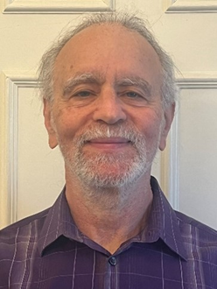

Ron Shapiro is an award winning retired English and Creative Writing teacher with over 40 years of classroom experience and a Fellow of the Pennsylvania and Northern Virginia Writing Projects, he now mentors students with college essays as well as teaches Memoir Writing at OLLI through George Mason University. In 2011, he received Cornell University’s Outstanding Teacher Award. He has published writings in The Whole Word Catalogue, More Strategies for Teaching Writing, NoVa Bards 2022, NoVa Bards 2023, Gatherings, Poets of the Promise, Poetry X Hunger as well as two chapbooks: Sacred Spaces and Wonderings.

At the Border
My mother pushes me closer
To the rusted iron fence. My
Face scrapes against its cold
Surface. The Mylar blanket
Found abandoned on the ground
A day or two ago, I’ve lost track
Of time, is too big and I almost
Trip over the silver material.

My pink hat keeps me warm
Though seems out of place
Among all these drab and ugly
Colors that surround me.

Someone on the other side
Of the fence is handing out
A colorful sweater and all
I can feel is the pushing
And shoving of my friends
And family. There are so
Many hands. I count fingers
And stop at 20 since that’s
As many numbers as I know.

I feel sad and wonder why
Won’t they let us through
To the other side? Why do
They hate us? Leave us
Here in the rain, the mud?

I had a little rice for dinner
Last night. Hunger is a word
I did not know until now. My
Stomach makes strange noises
At night. I drink dirty water
To quiet it down. My belly
Hurts sometimes. I want to
Go home but my mother says
We can’t. She says once we
Get to the other side of the fence,
Our lives will be better with a
Place to live, clean clothes to wear,
And yummy food to eat.
Cont.

But my ribs feel crushed
Against these iron bars,
I find it hard to believe in such
A dream. If you could see through
My eyes, you would know how it
Feels to be lost and without hope.

Here Comes the Rain by Ron Shapiro

Now there’s a sound
I haven’t heard in weeks:
The patter of rain drops
Dancing atop aluminum
Guttters, car hoods, windshields,
Thirsty leaves, parched roots,
Dried out bark, even offering
A shine to the dull black asphalt.

Before the storm began,
I sat by the tree outside
And listened to her song,
A loud buzzing vibrating
Up into the tallest branches
Which had been silent for days.

I smell the welcome wisps
Of wind stirring up the stillness
Of a scorching day.
The taptaptapping of falling drops
Increases like a hundred drum
Sticks tapping the snare. I look
Out the window and wonder if
Puddles will form in this heat?
Looks now like braille as the drops

Bounce off the road leaving
Drop-prints behind.
Thunder and lightning!
Water wraps around
The yellow curb rushing to
The sewer grate.

On the street, raindrops
Plink and plunk---it’s a beautiful dance.
Whirling dervishes in motion.

And now the moment changes,
What was dark and grey begins
To brighten. Tree leaves dripping
With water. Gravity propelling
Individual drops to the ground.

I close my eyes and listen.
Each drop on each leaf
Creates a different sound.
A rhythm as ancient as
The first drops on the first tree.

The rain slows to a drizzle.
All the branches laden with leaves
Sure seem happy.
Maybe trees do smile.

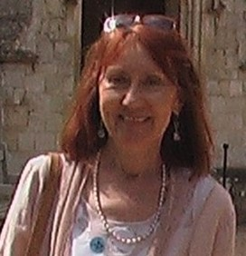

Sue Hassett is a retired teacher of English to students from around the world. She enjoys writing short stories, poetry and occasionally articles. Her work has appeared in various publications, including Fictionette magazine, Scribble, Crystal, All Your Poems, The Lady and The People’s Friend.
She prefers for the most part to write positive, upbeat fiction. She currently lives with her husband in Suffolk.

Winter Days

Winter days cling with icy fingers,
Spindly limbs of naked trees reaching into pale, morning sky.
Grey roof tiles dappled with glittering frost,

Sparkle in muted morning light.

Chilled air, sharp as broken glass
Bathes a world of faded colour.
Scattered remnants of sodden leaves,

Littering the grass.

A dazzling golden orb
Hangs low in the watery sky,
Huge and yellow as in a child’s picture book,
Though with barely a trace of heat.

Winter darkness descends with a cup of tea,
Evening by four o clock.
Another short span of daylight passed.
People rushing home with misty breath and chilly feet.

There are those who savour this time of year,
Huddled like mummies in layers of cladding,
Rushing home to heavy curtains, drawn against the night.
Relishing both biting chill and rosy fireside glow.

But not me, as I shiver and shudder with cold,
I’m dreaming of dancing daffodils in frilly, golden frocks.
Dreaming of warm air and long, light filled days,
Dreaming and longing for Spring.

Reflections on Time
by Sue Hassett

Time is shorter than you think.
Those golden, sunlit days of summer quickly pass,
So seize them while you have the chance,
Before the dove grey cloak of dusk descends, too soon.

Flowers flamboyant colours fade to ash.
Petals wilt and wither.
Winter always comes with damp and chilly fingers,
To smother all beneath its weary weight.

Nature’s mirror, life too is fleeting.
So many dreams unfulfilled. So many chances lost.
But there’s always tomorrow, I hear you say.
Until one day, there isn’t.

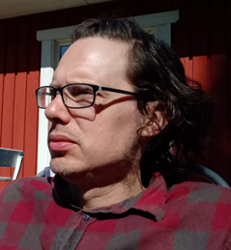

Andrew Senior is a writer of poetry and short literary and speculative fiction, based in Sheffield, UK. He lives with his wife and offspring and writes whenever he can find the time to do so. He prefers it to talking. His work has recently appeared, or is forthcoming, in various publications, including Isele Magazine, Postbox Magazine, Vaine, Abridged, The Heartland Review, The Frogmore Papers and Litro Magazine.

Saturday lunchtime remembered

Grandma did all the talking,
sitting in her chair, lighting up again,
telling the story of the cupboard
I once climbed in, having removed all the food tins
- a toddler, ten years since –
whilst me and him sat,
half listening.

Her voice mingled with the extractor fan, extracting
fumes from her frying pan, but not the smell
of ciggie smoke, or the sound of Terry Wogan
on low, and outside the ceaseless chirrup
of backyard sparrers, scuffling at
white breadcrumbs
she’d put out for their delectation.

With lunch done, he said that me and him
would pop round the corner
for a swift one and at the Mason’s Arms
he bought a bitter shandy with his pint
and, unlike her, he hardly said a word
but we were being men together,
is what it always felt like.

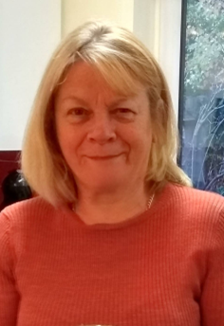

Jo Riglar. Born in Cork, Jo now lives in Surrey. A retired headteacher, she cherishes the opportunity to indulge her passion for writing and reading, especially poetry. She enjoys entering writing competitions and has had some success.

She is a regular contributor of flash fiction to Friday Flash Fiction and won their Easter poetry competition. She has had work accepted by Streetlight Magazine. In 2023 her poem My Uncle was a winner in the South Warwickshire Literary Festival Poetry competition and her poem For Sale was highly commended in the King Lear Prizes poetry competition.

The Bells of St Peter’s

There will be thrushes and bluebells in May
Squirrels and blackbirds and magpies at play.

There will be clover and primrose and bee
And bushes all thorny and mothering tree.

The bells of St Peter’s will sound through the field
Farmers will wait for and cherish their yield.

We will have sun then and earth will be warm.
We’ll sit in the garden and pray for the farm.

Think of the tired earth and such we might lose.
Call halt to the burning and crass overuse.

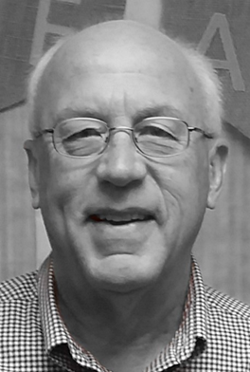

Duane Anderson currently lives in La Vista, NE. He has had poems published in Fine Lines, Cholla Needles, Tipton Poetry Journal, and several other publications. He is the author of ‘On the Corner of Walk and Don’t Walk,’ ‘The Blood Drives: One Pint Down,’ and ‘Conquer the Mountains.’

The Broken Branch

The branch looked like it was
hanging on the tree for dear life
weeks after being crippled from a storm.

There was no tree doctor
that could fix the damage done,
braces and bandages and tender loving care

would not bring it back to life.
The leaves now brown,
a few of the leaves having departed,

visiting the ground below.
The branch’s eventual fall,
maybe from another wind storm,

one finally decapitating it for good,
but for now, it was still part of the tree,
not having known anything else in its lifetime

Different Life Styles by Duane Anderson
He was outside watering his weeds,
when I held the belief
one was supposed to pull them,
but maybe I was the one who had it all wrong.
Both yards were green,
only it was a matter of what vegetation
one preferred growing in their yard.

Each took on a different philosophy of life,
he, the life of ease,
while I, one of hard work.
Neither one was wrong,
each rewarded from a different life style
from the amount of their efforts,
each totally satisfied.

Tis the Season by Duane Anderson
It was that time of the year,
maybe it wasn’t quite autumn by human standards,
but the squirrel had its own time calendar.

The acorns, fully grown on the oak trees,
and had ripened and began falling to the ground.
The squirrel held one of the acorns

in its mouth as it hopped through one yard
into another, then beyond, out of my sight,
spreading its fortune, one acorn at a time,

far and wide, not wanting to leave
anyone without in the neighborhood.
Tis the season, buried presents, for all to enjoy.

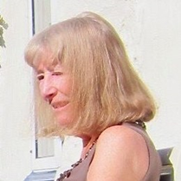

Lynn White lives in north Wales. Her work is influenced by issues of social justice and events, places and people she has known or imagined. She is especially interested in exploring the boundaries of dream, fantasy and reality. She has been nominated for a Pushcart Prize, Best of the Net and a Rhysling Award. https://lynnwhitepoetry.blogspot.com and https://www.facebook.com/Lynn-White-Poetry-1603675983213077/

Times Passed

As each day ends
I tick it off
on my calendar.
Finished!
Done!
Gone!
Lost!

But some will remain intact
to be pictured
sometimes
even heard
almost re-lived
as my memories.

If only
I could choose
the ones to remember,
open a window and look through,
revisit those days
and throw away the rest.
Watch them leave
forgotten,
lost,
gone
really gone!

But I can’t.
They’re self selecting,
those memories of
passed days
ebbing and flowing
outside my control.

Meditation On Autumn by Lynn White

I look into the river
and see how my reflection
moves helplessly in its flow.
Its moved and changed,
but left stationary,
not moved along
like the fishes
and pebbles
and floating leaves.
Disturbed and abstracted
my image fades and breaks
with the images beyond me.
I feel in danger of being broken up
and washed away
leaf by leaf.
The sweet watery sounds should ease my spirit,
should shut out the babbling inside me.
But even as I put my hands
over my broken ears,
I know that winter
will find a way
inside
in any case.



Sarah Cope is a novice writer of Child and adult fiction; she is an internationally published poet, featured with the best new poetry from writers all over the world. She has a menagerie of rescue animals that feature in her children’s books. A previous manager in the hospitality industry, Sarah was forced to resign from that career due to a chronic illness. `Strike1 Strike2 Strike3 I’m Out’, being one of the very first pieces Sarah wrote, and her first published piece. Sarah’s passion for writing evolved from poetry to children’s fiction and now adult fiction.

Oh dear, oh my, little Magpie

Oh dear oh my
You poor little magpie,
1 for sorrow is what is said,
And here you sit solo twitching your head,
For where is your sweetheart
Shouldn't you be together not apart
As the rhyme suggests
2 for joy is what comes next
Oh my, oh yes
A pair of magpies
that's what's best
Sitting together twitching your heads
Until 3 for a girl and 4 for a boy pop out their eggs,
In which case you'll need to build yourselves a pretty big nest.

Let's hope the remainder of the rhyme rings true
And your family will be blessed too
With precious metals that you'll find and fetch
5 for silver 6 for gold or so it's said to allege
the glistening so mesmerizing so hypnotizing
You must have it, To stash in your collection that's ever rising
Safely hidden in a location Mr magpie will not be disclosing or advertising.
Because 7 Is the secret he plans to continue hiding

Hop on-board over Thinkers by Sarah Cope

A warm Welcome aboard the over thinker to all our guests,
Especially Mr insomnia, and Mrs over thinker, both frequent flyers and our VIP guests
I'll be your minds captain for this flight, through awake all damn night,
And then on to good mornings beaming bright resort in daylight,
We have no nap-overs or drifting-offs scheduled this is a long-ass-haul, direct flight,
Emergency exits are located in the right and left ear, emergency lights,
Are located along the optic nerve in case of loss of power,
We can also deploy an emergency slide down the nostrils should we encounter,
An emergency landing over the cerebrospinal sea,
Otherwise please fasten your seatbelts and enjoy tormenting this mind with me,

Dear passengers this is your captain speaking,
we are experiencing some frustration turbulence,
And some drowsiness daydreaming,
this is Likely to continue until 4am so please remain seated,
As our head is hitting head on, stormy pillow clouds, and alas
A tossing and turning tornado has formed in our flight path,
Forcing us to go around the temporal lobe which will mean a delay to our arrival,

Passengers you can now lift up your eyelids once the kettles foggy fog,
Has cleared you'll be able to see the sacred sea of coffee,
And as we loop around the kitchen island there shines a good morning's sunrise,

Passengers we have arrived at our destination, good morning,
Upon the irises horizon is the sunrise dawning,
Here the local time is 5am and the current temperature is about 36 degrees,
Welcome to our new guests and a warm welcome back to our 2 VIPs,
We hope you enjoy your stay here at the daytime resort,
Oh don't forget to checkout our duty free thoughts
On your way out, I've been your mind's captain
Remember time flies when you're having fun aboard this mental contraption
So hop aboard this mind if you are to an over thinker,

My inner child by Sarah Cope

Do you remember when I was younger I was so carefree
Wild at heart with not an ounce of fear or anxiety to be seen,
I thought I was invincible!
She, that girl back then she was, incredible!
She was Formidable! She was unstoppable!
Yet, she loved with all her heart, and cared with her soul,
I miss her she was imperfectly incomplete and yet whole,
She often reappears in my mind's eye,
And I wonder If I'll ever see her smile again at all,
Or feel that laughter she once felt, you no that real carefree laughing,
That makes a child's cheek ache, from smiling as they chuckle laughing,
Or when your sides were in stitches as your doubled over, Laughing,
I wonder if? I as she, know I mean me as her, or is it her as I, had laughed together in passing.

She's, created memorable memories, of such happiness merely being here on the planet,
A true adventurer, I was a Tomboy often spotted in her natural habit,
Like in the trees as I climbed them to the top, or she would run through all the creeks, brooks and woods,
In my little jelly sandals, she took strides with such ease and strength,
Strides I wouldn't or couldn't even attempt to try and step,
Because i might do myself a mischief like pull my back, god does it ache,
Or maybe I'd ruin my shoes or my hair could fall out of place,

Good god why can't I just go back to being that fearless,
Vivacious, even slightly Ferrell , carefree, tree wrangling, dangling Tom girl,
Because she, well we, know I. I was such a happy little girl,
But somewhere across the paths of time we lost one another,
Now I feel like she and I are simply strangers just so happening to cross paths,
On occasion, like when I stare into the looking glass if I search hard enough,
I can still see some little quirks, like the crown in her fringe causing the hair to tuft,
Even in these weary old eyes, I can still see that glint of mischief, she would get,
In the corner of those big beautiful green eyes
And sometimes when i smile i still pull at those cheeky dimples for her,

She remains hidden away under a mask of wrinkles, lines and a washy complexion,
Basically a washed up old mare, but who knows maybe with some affection,
And a little more attention, maybe my little girl will come and meet this old mare,

Cont.

I wonder if she'll recognise who I, well we, know who I've become, I wonder if she'll care,
Or will she to recoil from our reflection in utter despair,
I wonder if she'll be proud of the woman she helped build,
Or will she stare at me In disappointment, feeling let down and unfulfilled,
All these questions I often ponder when I'm sat in front of the looking glass longing for her,
I no I'm still not quite completely, complete
But I'm working on it, like an entrepreneur
Hopefully one day her, mine, actually our puzzle pieces will finally align,
so we, My inner child and I will be reunited regardless of the logistics,
Either complete, or incomplete, I am indifferent,
Or maybe only 75% of it is done,
Whatever the sum we will be back together as we should be. Whole as one.



Catrin Mari is an autistic, Welsh-speaking social scientist based in Cardiff, Wales, using poetry to communicate research in accessible ways.
Her poetry often explores a sense of place, shifting identities, and under-appreciated historical figures.

Telling the bees

In memory of beekeeper Eric Neesam

She was telling the bees of one
on the journey we all must travel.
Knuckles rapping against slats, she
shrouded each vibrating hive:
Draped its hum in the drip of sung syllables.

She awaited the rising
gold-ringed sun:
That dawn fire, hazy with birdsong and scented melodies,
with souls buzzing between flower stems which nod like sleepy children.

In the morning,
we drizzle sticky butter knives,
scraping breakfast toast into a whirl of flowers and sweetness.
Our spoons clink against tea cups,
honey pooling its dance into the steam, then rising to a comb at the ceiling.
Outside, a new chapter stretches its petals:
an eye opening up the new day.

Twenty-nine (bloodlines). By Catrin Mari
To my twin sister on our 29th birthday, to remember that we were born at 29 weeks' gestation.

In lanugo language we communicated:
between tiny speckled lights, swimming, filling, between
translucent skin, the long white lacuna gap between us:
The accidental space in our linguistics, stretching
across the medical-clean space, blank
slate page; lucent though we weren’t quite lucid, yet.

Our dreamscape of soft-beating wires,
humming bronchial lines, the plastic umbilicus
linking us to ourselves, but not yet to each other,
Even though we were two halves of the same lungs.

In clear cocoon-shells we lay muffled: feeling, like divers absorbing the beeping;
taps of submarine shoes in a strange new world.

But soon,
our coral veins touched: delicate brains dancing to the insistent beeping of
each other’s heartbeats:

I’m here. I’m here. I’m here.

Anchored to the earth, we made our own world: the snug bunk bed cabin of a bedroom where we dreamed, connecting, breathing the same tunes to the tinny sugar-plum signals from the music box. Swimming: holiday sunlight scorching our ripe skin, as we went diving where once we did the opposite, like fish forced out of water: gasping...
Inhaling, Exhaling…scaling new seabeds ...we shared- the bubble-welling excitement of birthdays, jellyfishing our dances. We knotted plastic pearls, the delicate taps of our shoes
echoing each other in morse-code satin, and whispers.

Now we’re connected by wifi wire nets as we hold each other bobbing on screens
We lean into windows, the lights of each other’s rooms comforting now and not so harsh- separated by map lines, we have defined our separate selves, swum our own paths,
punctured our own skin in ink like water, to draw ourselves by our own definitions.

We’ve moored our own minds in our own home towns, and stepped through their streets walking, drawn towards water, trying to wash memories that our bodies still remember, our bones our homes for twenty nine years like the twenty nine weeks in which we were grown-

But star scars dot our hands: mapping our history like code.

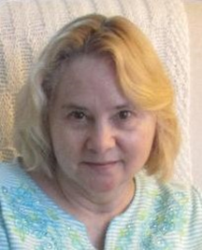

Bobbi Sinha-Morey's poetry has appeared in a wide variety of places such as Plainsongs, Pirene's Fountain, The Wayfarer, Helix Magazine, Miller's Pond, The Tau, Vita Brevis, Cascadia Rising Review, and Old Red Kimono.
Her books of poetry are available at Amazon.com and her work has been nominated for Best of the Net in 2015, 2018, 2020, and 2021 as well as having been nominated
for The Pushcart Prize in 2020.

To Paint The Sun

In the afterglow near the day's
end a wren alit on a branch of
a catalpa tree outside my bedroom
window and whispered to me in
my dreams, sparking a fire inside
of me to paint the sun in a sky so
forever young. No cadence of the
wind in the sweet afternoon; only
me and my paintbrush arc after
arc and one stroke after the other
where no waking world can
disturb me, and my creation opens
itself up like a flower before anyone
could look upon it with adoring eyes;
the path to my heart so alive in the
unbroken peace I have to myself.
Morning glories nod their approval,
and in my blessed solace of time
not a soul has risen to steal me away
from my idyllic circle.

White Lilac by Bobbi Sinha-Morey

A dream star to the one who loved
her, she wore a half smile on her face
when she glowed by day, she a delicately
boned thing, a pale blue in her eyes that
lit only when she saw the sunrise.
The last time I saw her it looked as if
she trembled in the wind, her gentle
spirit fluttering so easily inside of her
like a slim candle's dancing flame.
Once I'd given her a rare gift she
hadn't expected and she held it so
daintily to her chest as if it had fallen
from the heavens and she didn't want
it to break. I knew she needed a friend
and I didn't live that far away. She drew
the sun to her like a white lilac absorbing
the cool warm air and she had a such a
sweet calmness about her. I thought of
making a petite coconut cake with my
own hands, and visiting her just so it
would brighten her day.

The Soft Air of Daylight by Bobbi Sinha-Morey

In patches of silence I waken
my senses to a new beginning,
far away from memories that
tore me apart like lotus petals
whipped and lost in the wind.
Yesterday has unraveled a life
I used to know, a chapter I
wanted to blot out like a dismal
dream and stir my thoughts to
a garden or pool of water so
peaceably still as if they so
idyllically hummed under the
warm caress of the sun. Like
them I want to breathe in the
soft air of daylight, rest my
lithe spirit, let it brighten
and heal under the sky like
it had so shyly never done
before.

Dr. Emily Bilman is a widely published and anthologized author of poetry, literary essays, and short stories. Her PhD dissertation, The Psychodynamics of Poetry, was published by Lambert Academic in 2010. Slatkine published La rivière de soi (2010) in Geneva. Modern Ekphrasis (2013) came out by Peter Lang Academic, CH. Her poetry books, A Woman by A Well (2015), Resilience (2015), The Threshold of Broken Waters (2018), Apperception (2020), The Undertow (2023) were published by Troubador UK. Her sonnet, “Pathfinder”, will arrive on the moon’s southern pole with a NASA time-capsule in mid-2024. See Lunar Codex! http://www.emiliebilman.wix.com/emily-bilman


Museum-Mazes

Through the open museum-mazes, I gaze
at the chess-players carved in walrus-tusks
who gaze at me with wide-eyed awe.

In another window, a fate-resigned boy
ties a string around the clutched tunic
of the kouros right before him, gazing side-
ways in introspective self-doubt.

The scapegoat-sacrifice will spill
blood on the shattered pediment.

Torn with self-resigned pathos, a naked
horseman curbs his horse, points
an introspective index on the horsemen.
Like the motion of interconnected bones
the procession is ready to set off.

In through another open maze, I gaze
at the sculpted bird on the death-mask
that will carry the warrior-king to eternity.

Water Lilies by Emily Bilman

Holding Dali’s lobster-telephone,
you unroll the cabled wire and refuse
to abandon me. Tied as you were,
you could not contain the sand-
strewn remains of the webbed-day,
the fallen frame of a starfish,
the dried-up crab, the parched
oranges, the island-oysters shut
to ramblers. Yet, like a rueful child,
apologetic to his mother, you bared
your back and bent your head but
neglected the negotiation we held.
And I cannot give up until we reach
the dream of the snow-tiger leaping
into the prelude of my childhood,
the petalled pond built with brick-words,
shielded with thick-veined leaves,
their circled receptacles spiked.

The Osprey by Emily Bilman

The white bird-fish deployed huge wings over the teal sea, ready to take off with sun-down. The bird-fish seemed to have escaped from the cold waters above the Mariana Trench where Challenger once landed amidst those simmering depths. White wings shielded the bird’s milky white, thick, and opaque flesh. The gigantic fish-owl could not have landed on the wooden plank from the lower regions of the trench where the fish and squids are tinier, transparent, and despite their miniature sizes, sometimes luminescent, to wade off predators and attract mates. The white fish-bird was keen to take its flight towards the mist-hidden horizon, far away.



Pema Tshering, a teacher at a Higher Secondary school in Bhutan, has made significant contributions to Eco centric literature. His poems and writings often feature prominently on various online platforms.

Is age number or excuse?

In the walk of life, where stories unfold,
Age weaves its threads, both precious and bold.
For some, it's a number, a mere counting of years,
While others find wisdom and shed youthful fears.

Age is not a matter, or so they proclaim,
As hearts stay vibrant, aflame with life's flame.
Yet, truth be told, it carries weight, too,
With lessons learned, experiences anew.

But in the grand scheme, what truly prevails,
Is not the ticking clock or the passing of trails.
It's the fire within, the spirit unbound,
The determination that knows no rebound.

For age may bring wrinkles, a touch of gray,
But it cannot dampen a determined soul's sway.
With each passing day, we can choose our path,

Is age number or excuse? (Cont.)

Embracing challenges, defying life's wrath.

The young may dream of what lies ahead,
While the old reflect on the paths they've tread.
Yet, age matters not when we strive to achieve,
When we summon our will and never deceive.

Determination, the force that breaks age's chains,
Unleashes courage amidst life's gains and pains.
It conquers the doubts, the whispers of naysayers,
With grit and resilience, it writes our own layers.

So let age be a canvas to paint with desire,
With dreams that ignite and hearts that aspire.
For when we pursue our passions with might,
Age becomes a mere backdrop, fading from sight.

In the journey of life, age finds its place,
But determination weaves a triumphant embrace.
No matter the years that may come to pass,

With determination, we'll conquer, surpass.

So heed not the whispers, the doubts that surround,
For age is not a matter, but determination profound.
In the rhythmic of life, let your spirit play,
And watch as it blossoms, forever and a day.

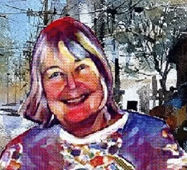

Joan McNerney’s poetry is published worldwide in over thirty-five countries in numerous literary magazines. Four Best of the Net nominations have been awarded to her. The Muse in Miniature, Love Poems for Michael, and At Work are available on Amazon.com. A new title Light & Shadows has recently been released.

noon day demon

after police cars careened downtown
sirens screaming across streets
neighborhood schools locked down

after press reporters, photographers
combed the vicinity canvassing
live witnesses or local authorities

after helicopters lifted the injured from
wired baskets to trauma centers while
gleaming black bags were carried out

after the gunman was shot down
but no one could understand his rage
camouflaged by quiet politeness

after everyone remarked how bright
blue morning had turned to blood red
afternoon marked by thin yellow tape

after blinking lights ashen faces
cries of distress faded into gray
there was nothing to do but return

to business as usual.

Crazy Hot by Joan McNerney
Ravema. New York

During this summer bales of hay explode
crops scorched livestock slaughtered early.

We shuffle through grocery stores. Limp
lettuce mushy tomatoes languish on counters.

Prices rise inexorably when we drive to
gas stations where fumes fill our nostrils.

My throat is dry and coated with metallic taste.
I guzzle a bottle of ice tea, saccharine sweet.

Our town park floods with children spilling over
brown grass their shouts cutting the air.

Laundry comes out piping hot from
the dryer zippers burning my fingers.

Clumps of wrinkled clothes wobble on chairs.
Unopened mail and dust cover my table.

A rayon nightgown sticks to my skin while
fans push warm air brushing my face.

The shrill of cicadas drown the night as
I wait now to melt into dark oblivion.

Reservoir by Joan McNerney

I can no longer separate the poem from that day
both imperfect lonely paraphrasing.

Perhaps you can imagine air dense occasional sun
on face hard brown grass at the reservoir in
New England trees spill their leaves like many hands
falling in despair gulls crying crying at New England
reservoir rippling rippling how old I am becoming
searching still searching.

Too tired embarrassed nude inside why say anything
annoyed amazed at circles with circles diffusion
of leaves rings of water movement of people moving
moving all this moving toward no exact point
only this cluster of conjecture.



Joseph C Ogbonna is a prolific
poet from Nigeria. He is widely published in journals, magazines and in online blogs. he currently resides in Enugu, Nigeria.

The Canadian Indian
I am Canadian Indian.
I owe my origins
To the Canadian earth.
Its high and lowlands,
Its short grassy slopes,
And its freezing snowy plains.
I am who I am
Because of its peculiar
Flora and fauna.
The wood cutting
Architect beaver,
The awe inspiring
Decimated buffalo,
The rare and deciduous
Ginseng and the north
American larch.
I was dispossessed
Of my endowed heritage.
Notwithstanding,
I remain who I am.
I am Canada, and
Canada is within me.

The Canadian Inuit by Joseph C Ogbonna
I am Inuit.
I am the offspring
Of Arctic and subarctic
Canada.
The Icy and wintry regions
Are no doubt my traditional
Strongholds.
I inhabit them like no one
Else can.
The igloo is my fortification,
The snow my bricks.
My heritage was stolen,
And still to the depths
I was relegated.
But Canada remains
My identity, and I
Exhibit nothing else
But the Canadian spirit;
The ancestral Inuit spirit.
The dexterous creators of
Molten birds and mammals,
And the age-old marine farmer.

The Canadian Metis by Joseph C Ogbonna
I am metis;
The brood of the conquered
And the conqueror.
I convey your words to
Canada, in a tongue she
Clearly understands.
I always clad the freezing
Stranger,
And I negotiate their transactions.
The hospitality of the
Fridges of Canada is
Impossible without me.
My michif and culture
Are near obliterated by the
Insular imperialist.
But I stand nevertheless
As the melting pot of the
Prestigious Canadian identity.



Ann Garrett is the author of fiction in both the children and adult markets.
Ann’s poetry has been published in the anthologies, and in poetry magazines.
In the children’s market, she authored the picture book Keeper of the Swamp and co-authored the picture books:
Her children’s poetry has appeared in Kwil Kids publishing, PKA’s advocate, Poem Train, Boy’s Quest, Mr. Marquis’ Museletter and short editions.
Happily married, Ann lives and writes in southern ca.

No Fairytale Ending

This chapter of our lives didn’t just end
but the whole story did.

You just literally
dropped the book
and kicked it aside,
never wondering
if the story
would
or could
lead to that great climax or
happy ending.

Never knowing
that when this book
was discarded
that it would be lost
amidst
the
rubble.

Unfulfilled by Ann Garrett

Maturity morns
what youth squandered.

A constant striving for
unfulfilled dreams
unfulfilled love
an unfulfilled life.

I always wanted more for you
but now the time of your being is gone
and I morn for you my friend.

I look back now
over years that have passed
for what was once a bright clear note

is only
silence now.

My heart is laid bare.
Black iris on white snow.



John RC Potter is an international educator and gay man from Canada, living in Istanbul. His poems, stories, essays, and reviews have been published in a range of magazines and journals, most recently in Blank Spaces, (“In Search of Alice Munro”, June 2023), Literary Yard (“She Got What She Deserved”, June 2023), Freedom Fiction (“The Mystery of the Dead-as-a-Doornail Author”, July 2023), and The Serulian (“The Memory Box”, September 2023). The author has over a dozen upcoming publications in the coming months, including an essay in The Montreal Review.
https://author-blog.org/
https://twitter.com/JohnRCPotter

Fatal Traction

It was a blustery, wintry evening
late in ‘87, as I recall,
when your car thundered in and picked me up
to do some shopping at the nearby mall.

You were driving a big boat of a car,
that slid and skid all over the street,
no doubt given to you by your dad,
just an old cast-off from his taxi fleet.

The heater just barely gave off some heat
and ice was forming on my nose tip,
driven by a self-styled Glenn Close,
with your carrot-coloured hair, what a trip!

With white fingers gripping the steering wheel,
you drove your chariot with such glee,
with me as your own Michael Douglas,
a pleading prisoner, on bended knee.

How can you drive such a death trap? I asked.
Wheels that spin and without any traction!
Cont.

Just then the proverbial penny dropped:
our friendship was a fatal attraction!

A movie flickered through my spinning mind
as my driver took a course of action;
she parked with much ease when the engine died,
leaving the scene of that fatal traction.

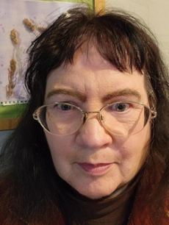

Janet Guastavino is a native Californian and a fifth-generation San Franciscan. She has been writing poetry for the past seventeen years and has been published digitally and in hard copy. She curates a web site called “The Crone’s Words,” that features poetry and flash fiction about mental health and emotional wellbeing, written by women over the age of fifty-five.

All Things Are One

Here lies a faint sigh
planted in damp soil,
a pallid breath,
a wish undone

Sieved fingers in water
the satin cool flows clear,
a vital force
likened to none

Red wing on a fence
—the swoosh of dried wheat grass—
up-soars in flight
through dappled sun

The candles flicker,
and gutter in pale dawn,
mist is rising
the night is done

Here’s the reason why
the beast, the best, give way
—before each soul,
all things are one—
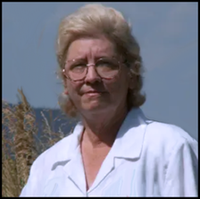

LaVern Spencer McCarthy, has written and published nine books, five of poetry and five of fiction. Her work has appeared in Writers and Readers Magazine, Meadowlark Reader, Agape Review, Fenechty Publications, Metastellar. Down In The Dirt, Mouthfeel, Fresh Words Magazine. Wicked Shadows Press, Midnight Magazine. and others.
She resides in Blair Oklahoma where she is currently writing her sixth book of short stories.

A Field Of War

A hallowed field of war is never still.
Tall grasses rustle from immortal pain.
The earth moves sharply with a haunted will.
A soldier's ghost bestirs the wild terrain.

Tall grasses rustle from immortal pain.
It rises from below on waves of fear.
A soldier's ghost bestirs the wild terrain.
His ghastly screams make other ghosts appear.

It rises from below on waves of fear,
a never-ending sound that chills the air.
His ghastly screams make other ghosts appear.
The lonely cries commingle with despair.

A never-ending sound that chills the air,
the endless wailing makes the flowers weep.
The lonely cries commingle with despair.
We find the ones who perished do not sleep.

The endless wailing makes the flowers weep.
The earth moves sharply with a haunted will.
We find the ones who perished do not sleep.
A hallowed field of war is never still.

Published National Federation of State Poetry
Societies, Inc, Encore--2018



John Grey is an Australian poet, US resident, recently published in Stand, Santa fe Literary Review, and Sheepshead Review. Latest books, ”Between Two Fires”, “Covert” and “Memory Outside The Head” are available through Amazon. Work upcoming in the McNeese Review, La Presa and California Quarterly..

BRAIDS

On a Bahaman beach,
a woman braids hair,
patiently and expertly,
for whoever’s willing to pay
a price lower than any
fancier Nassau salon would charge.

She even laughs, tells stories,
as she goes about her business,
engaging the teenage tourists,
mostly from wealthy
and white American families,
with how much they remind her
of her lovely grandchildren.

The young girls
take to the buoyant atmosphere,
the sun, the sand,
and a look that has always
sparked their curiosity
and now, far from home,
they can live up to
a years-long dare.

When done, they’re
no more a local,
the woman’s grandchild,
that they were when
they first sat down
in that inviting chair.

But the braids will shock their parents,
be worth a few looks in the mirror.
And back home, they’ll be talked about.
But the novelty soon fades.
Sometimes after the tan.
Sometimes before.

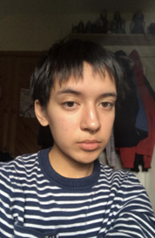

My name is Bon Roslan, an openly queer 19 year old from Oxford. I have always been an avid writer; indeed, you’ll find me spend most of my time sketching story dialogue and poetry during quiet hours at work. When I was 16, I set up a poetry society for the other poets in school. I draw influences from my early muslim background, socialist theory, being a person of colour, my queerness and an unconditional love for people.
This poem is the reconciliation between me and my mother, and how I left home to escape her so I could be ‘free’ in my queer identity. It is a common issue many queer folks go through and I wanted to let myself address my own situation as kindly as I could. It is about the delicacy of being a child to a mother and the mother to a child.

The Soup and The Pita

When I was small,
My mum would nest
An ear to my stomach and
Recite the stories between
The soup and the pita.
Her palms tucked magic
Into each canyon - washed
With shea butter, so
Spoke healings to the
Chatters within me.
Sometimes, in her silliness,
She scolded them until they
Vanished! It would make
Me laugh a hundred times
Until my lungs inflated large
Enough to live in. Following
This method, many fevers
And greeds disappeared as the
Wise healer laughed in celebration. But
In all her wisdom, pebbles kept
Getting caught in wheels and
She had challenged time
Too soon. It is, therefore, why the
Healer felt the earth bend when finally
Noticing the cracks in
My skin, hers, the
Razors on my head, and
What happened when I listened to the
Accents within my stomach. It was
Obvious like the flesh of
A raspberry, squashed onto white wooden
Floors. I shrunk myself
Into the gapes of my own
Abdomen. Then, storming up a flight of
Nerves, I slammed my
Secret pleads
Shut, aggressively, where nobody
Could hear. I let a trail of
Bread crumbs follow behind
But there was no entrance to
My words. The door was no bigger
Than sand. And sand is no
Smaller than time. And,
Amongst myself, I tried forgetting
Her voice as I would forget
How to speak at all.

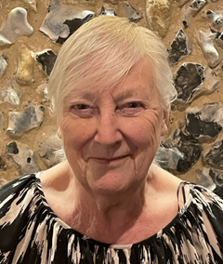

Sarah Das Gupta is a teacher living near Cambridge, UK, who has also taught and lived in Kolkata, India. Her work had been published in twelve countries and many magazines, including 'Black Poppy', American Poetry Review', 'Bar Bar',
'Green Ink', 'Danse Macabre', 'Humana Obscura', 'Creation', 'Paddler', 'Acedian', 'The Sirens Call' among others.

Somewhere
the first chill in the air,
I watch the swallows
circling in autumn skies,
now they are flying south.

the boats on the river
struggle against the autumn tide,
rowers dip deep, the current ebbs,
the cuckoo’s voice is long gone.

the leaves are in their glory,
blazing comets, before inevitable death,
the squirrel collects the last cobnuts,
flocks of starlings gather in grey skies.

somewhere you listen to the North wind,
playing Bach’s cascades of passion
or the first scatter of snowflakes
dancing lightly over the keys.

the darkness of winter approaches,
bare black branches scar the sky
a fringe of icicles hangs from the gate.
yet, buried deep,
the seeds begin to stir.



Patricia Walsh was born and raised in the parish of Mourneabbey, Co Cork, Ireland. To date, she has published one novel, titled The Quest for Lost Eire, in 2014, and has published one collection of poetry, titled Continuity Errors, with Lapwing Publications in 2010. She has since been published in a variety of print and online journals across Ireland, The UK, USA, and Canada. She has also published another novel, In The Days of Ford Cortina, in August 2021.

Bomb Song

An adventure through the darkened heart has its wonders
Screeching through success on common ground
Attractive happiness testing endeavour
For richer or poorer, whatever rings true.

Staying another day, pretentious flowering
Getting married on the sly nicely fits
A local celebration brings home the humour
Unfunny jokes bereft of wit cloy immeasurably.

Rose you are sick, right there in the head
Freezing apertures cover your crimes
Not blotting the copy-book of our shared history
Chilling over alcohol not meant for you.

Hitting on the forbidden, no respect for same
Respect cut and dried on a favourite plane.
Breezed like Sunday morning, relaxing skins
War, like an art, impedes itself.

Love disbelieved, is cut and dried. Physical facts
Erode the soul, however fleeting
Had it for better than most people
Waiving sympathy for the older reaches.

The constant reader buries loneliness
Satisfying a burnt success in earnest
Accessible speech on a white sheet of pages
Equal time to the outset, lighting off betters.



Bohumila Ottova has been writing poems since her teen years, but it took a lot of courage and persuasion to agree to self-publishing them. In 2014, comes out a collection of her poems in Czech under the title As if Nothing (Jakoby nic). She had three of her poems in French published in Revue Alsacienne de Littérature. As to the poems in English - they are patiently waiting their turn to be published.

Time Waits For Nobody

Time waits for nobody
And nobody waits for time
I’d be very rich
If for each lost minute,
I got a dime.

We rush, we run, we fly
Trying to be elsewhere
At another moment
And forget the dents in us
From time, that tireless rodent.

We’re straining our eyes
Looking far into the future
Hoping for something better
For a divine rapture

We’re blind to here and now
The shining sun, a caressing breeze
Think that like the oxen we must plough
Until our last breath, the final freeze.

Time waits for nobody
Just let it run, let it be
Slow down, stop, have some fun
Set the time and yourself free

Kings And Queens by Bohumila Ottova

I have no brolly nor a clue
What would be the next thing I could do
I’m waiting for my delayed train
And it’s pouring with the rain

The train is late, I’m getting drenched.
When you come and offer me your trench
You smile and place it above our heads
And so a green sky over spreads

Ref.:
This is what
it has always been
You are my king,
I am your queen.

We don’t mind t’ downpour, getting wet
a brand-new future poke its head
Our heartbeats will become as one
And fill our souls with lasting sun

I love your everything, I’m lost
Ever since the day our paths have crossed
Ever since that rain began
I am your girl, you are my man.

Ref.:
This is what
it has always been
You are my king,
I am your queen.

Time flies by and we’re now old
So many times our story was told
So many years, you’re still my heart
And I hate when we’re apart.

Our kids have grown and grew old
Our love’s more precious than gold
Stay in my arms, as you’re in my heart
It’s not the end, it’s just a start.

Ref.:
This is what
it has always been
You are my king,
I am your queen.

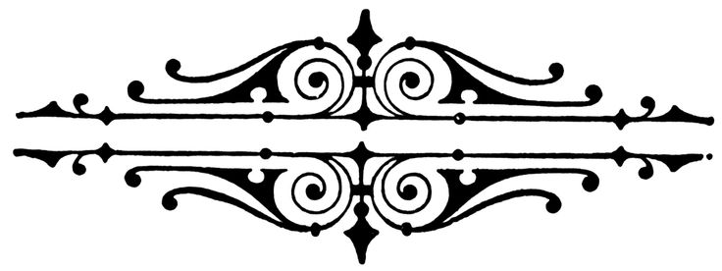



Guidelines
All Your Poems (Magazine)

We accept Poetry Modern and Traditional, if you have accompanying sketches or pictures please attach them as jpg. files.
A maximum of 4 poems on any subject should be sent at any one time.
All pages need to be numbered and show name and email address. In MS Word not PDF.
A short bio and picture must be attached to your submission.
We do not reject any submissions, if not selected they are held over for consideration to be published in a forthcoming issue.
We are a non-profit publication.
If your submission is accepted for publication, you will receive a free online copy of the magazine which you can download.
We do not claim copyright.
We do not accept or publish anything of a sexually explicit nature or erotica.
This magazine aims to give new and experienced poets an opportunity to be published.
Submission deadline 18th September for the October issue.
editor@allyourpoems.com submissions@allyourpoems.com

